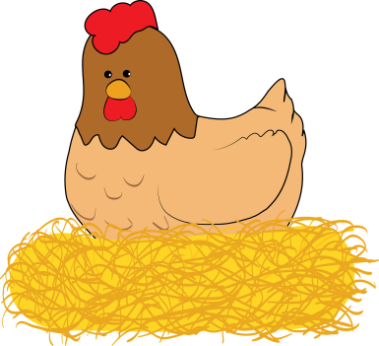
Egg Maths

Need:
Cardboard
Scissors
Tape
Paper clips
Colour Pencils / Felts
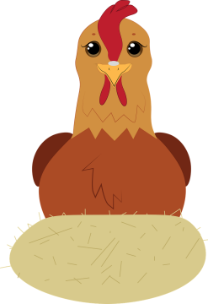
Prep:
Draw out 9 big chickens on paper
Draw out 27 Eggs
Cut out your chickens and eggs
Colour and decorate your chickens
Draw out 9 pieces of cardboard that match your chickens
Attach your chickens with paperclips up the top to the cardboard
On your eggs -
18 Eggs write a number
9 eggs write a mixture of + - x /
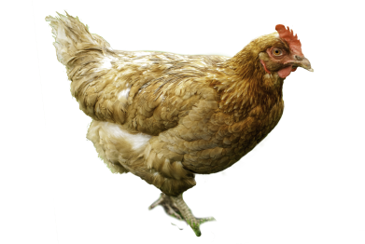
Place on the cardboard (but under the chicken paper)
2 Number Eggs and 1 Maths Symbol

How to play:
Put all the chickens created by all the groups into a pile in the middle of the class
Go around group by group and choose a chicken from the center until each group has 9 chickens
Each group can not pick one of its own chickens it created
Once every group has all their chickens then all the groups can open the chickens and start on their maths egg equations
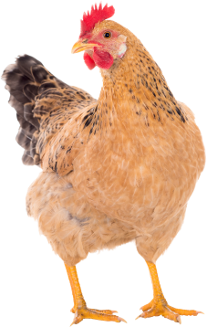
Our Groups Chicken Egg Equations Answers
1.
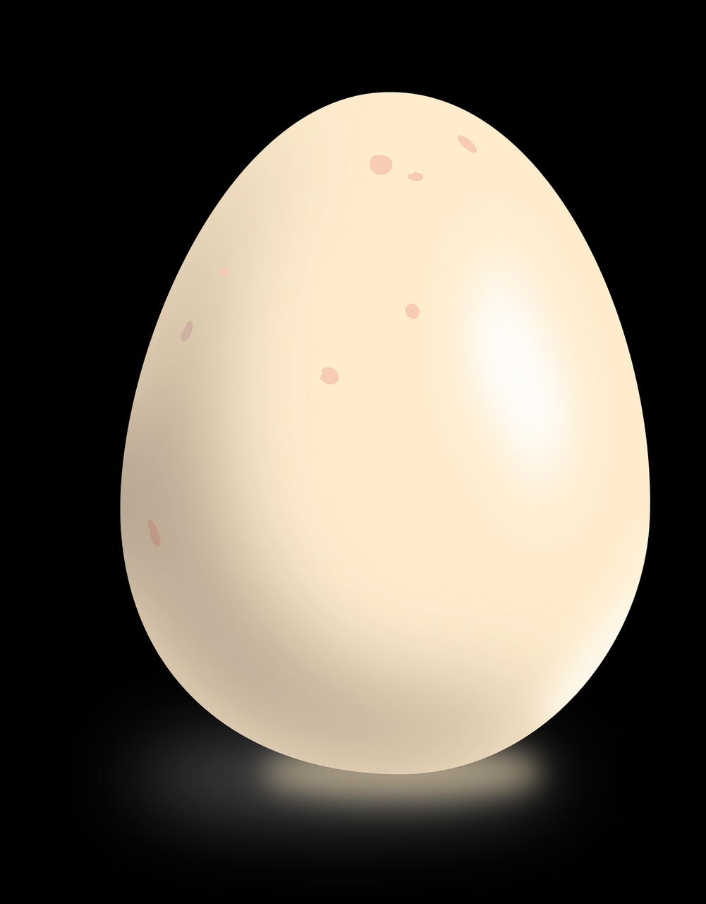
2.
3.
4.
5.
6.
7.
8.
9.

